• O.T3.2 ON LINE Capacity Building platform in Blue Growth;

Information about O.T3.2 ON LINE Capacity Building platform in Blue Growth;

- Description of the output in accordance with application form:
Self-Learning tool with available testing of knowledge on blue growth.

- Output indicator:
Number of business and research institutions involved/offering non- financial support.

- Due date in accordance with application form:
March 2023;

- ON LINE Capacity Building platform in Blue Growth description:
The Online Capacity Building Platform for Blue Growth is an innovative digital tool designed to enhance the skills, knowledge, and competencies of stakeholders in the marine and maritime sectors within the geographic region of Italy, Albania, and Montenegro. This platform aims to support sustainable development and economic growth by leveraging the blue economy, which includes activities related to oceans, seas, and coastal areas. Objectives of the platform are following:
- Enhance Knowledge and Skills: Provide comprehensive training and resources to individuals and organizations involved in the blue economy, focusing on sustainable practices, innovation, and technological advancements.
- Foster Collaboration: Promote cross-border cooperation and knowledge exchange between Italy, Albania, and Montenegro, facilitating the sharing of best practices and joint initiatives.
- Support Sustainable Development: Encourage the adoption of sustainable practices in marine and maritime activities to protect and preserve marine ecosystems while promoting economic growth.
- Promote Innovation: Stimulate innovation in the blue economy by providing access to the latest research, technological developments, and funding opportunities.
Platform key features are:
- E-Learning Modules: Interactive and comprehensive courses covering various aspects of blue growth, including marine spatial planning, sustainable fisheries, aquaculture, coastal tourism, maritime transport, and marine renewable energy.
- Webinars and Workshops: Regular live sessions with experts in the field, offering insights into current trends, challenges, and opportunities in the blue economy.
- Resource Library: A rich repository of articles, research papers, case studies, policy documents, and multimedia content relevant to blue growth.
- Networking Opportunities: Forums and discussion boards to facilitate communication and collaboration among stakeholders, including policymakers, researchers, industry professionals, and community organizations.
- Project Management Tools: Tools to help users develop, manage, and track blue growth projects, including templates, guides, and best practice frameworks.
- Funding Information: Up-to-date information on funding opportunities, grants, and financial instruments available for blue growth initiatives in the region.

Platform geographic focus is on programme area with possibility of scaling on other areas:
- Italy: Leveraging its extensive coastline and advanced maritime industries, the platform aims to boost innovation and sustainability in Italy's blue economy.
- Albania: Supporting the development of Albania’s marine and coastal sectors, focusing on sustainable tourism, fisheries, and marine biodiversity conservation.
- Montenegro: Enhancing Montenegro’s capacity in marine governance, sustainable aquaculture, and marine renewable energy.

Platform major benefits are:
- Improved Competitiveness: By building capacities and fostering innovation, the platform helps stakeholders stay competitive in the global blue economy.
- Sustainable Practices: Encourages the adoption of environmentally sustainable practices to protect marine ecosystems and resources.
- Economic Growth: Supports the creation of new business opportunities and job creation in the marine and maritime sectors.
- Regional Cooperation: Strengthens regional cooperation and integration, promoting a unified approach to blue growth in the Adriatic-Ionian region.
This platform serves as a comprehensive and accessible resource for fostering sustainable blue growth, enhancing regional cooperation, and promoting economic development in the marine and maritime sectors of Italy, Albania, and Montenegro.
Platform available online courses:
- Environment and economy;
- Environmental values and methods of development;
- Risk and insurance market;
- Blue economy – methodological approach;
- Financial management;
- Blue finance;
- Public procurement in Albania;
- Financial resilience;
- Marketing and branding strategies;
- Opportunities for blue economy;
- Technology for SMEs in blue economy;

Number of platform instructors: 10;

- Platform links:
https://smartadria.net
https://regrowmne.com
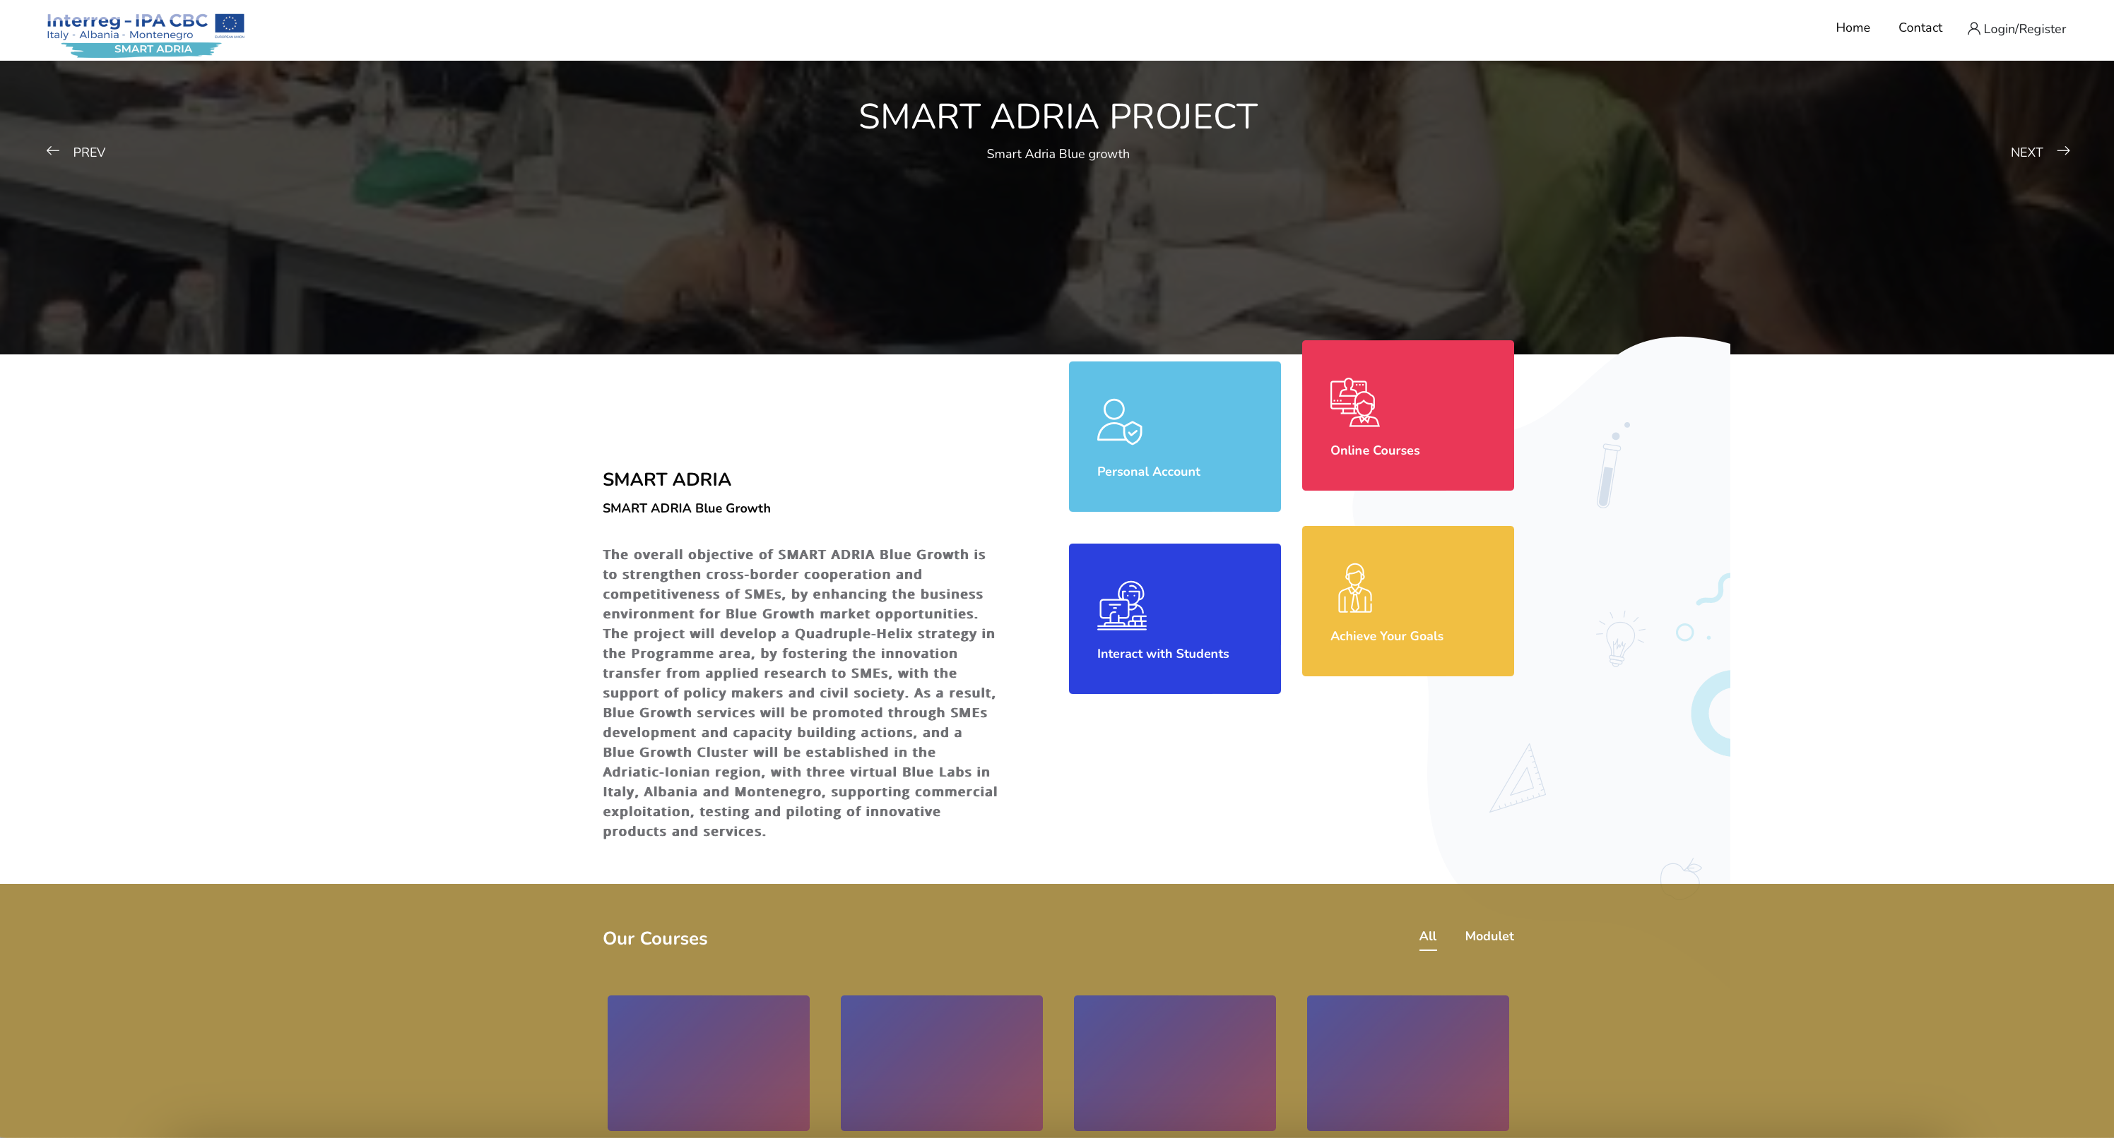
I. Introduction

The Smart Adria Blue Growth project is a pioneering initiative aimed at fostering sustainable development within the Adriatic region's maritime sectors. As the world increasingly acknowledges the importance of the blue economy, this project stands at the forefront of innovation and environmental stewardship. The core of the Smart Adria project is an online capacity-building platform designed to enhance maritime skills, promote sustainable practices, and foster innovation and collaboration across Italy, Albania, and Montenegro.

The Adriatic Sea, with its rich biodiversity and economic potential, presents both opportunities and challenges for the countries that border it. Italy, with its extensive coastline and advanced maritime industries, has long been a leader in marine innovation and sustainability. Albania, with its burgeoning coastal and marine sectors, is ripe for growth in sustainable tourism, fisheries, and marine biodiversity conservation. Montenegro, with its strategic position and growing maritime economy, has significant potential in marine governance, sustainable aquaculture, and marine renewable energy.

The online capacity-building platform serves as a central hub for these nations, providing a comprehensive suite of resources and tools to elevate their blue economies. By leveraging digital technology, the platform offers an accessible and scalable solution to educate, connect, and empower stakeholders from various maritime sectors. It aims to create a cohesive and collaborative environment where best practices and innovative ideas can be shared and implemented effectively.

Below, we will delve into the specifics of how the Smart Adria project is transforming the maritime landscape in Italy, Albania, and Montenegro. We will explore the key features of the online capacity-building platform, including its user interface, educational resources, and networking opportunities. Additionally, we will examine the broader impact and outcomes of the project, highlighting its economic benefits, contributions to environmental sustainability, and role in fostering community engagement.

As we navigate through these topics, it becomes clear that the Smart Adria Blue Growth project is not just a regional initiative but a model for global efforts in sustainable maritime development. By embracing innovation and collaboration, the project sets a new standard for how coastal nations can harness the potential of their marine environments while safeguarding them for future generations.

II. Regional Focus and Objectives

Italy: Leveraging its Extensive Coastline and Advanced Maritime Industries

Italy, with its extensive coastline stretching over 7,600 kilometers, presents an ideal environment for the implementation of the Smart Adria Blue Growth project. The country is renowned for its advanced maritime industries, including shipbuilding, port logistics, and marine engineering. By leveraging these strengths, the online capacity-building platform aims to foster innovation and sustainability within Italy's blue economy.

The platform will provide tailored educational resources and training programs designed to upskill the Italian workforce in cutting-edge maritime technologies and sustainable practices. Key areas of focus include the development of eco-friendly shipping solutions, the promotion of sustainable fishing techniques, and the enhancement of marine conservation efforts. By integrating these elements, the platform intends to ensure that Italy not only maintains its competitive edge in maritime industries but also aligns with global sustainability goals.

Albania: Supporting the Development of Marine and Coastal Sectors

Albania, with its strategic location along the Adriatic and Ionian Seas, possesses significant untapped potential in its marine and coastal sectors. The Smart Adria Blue Growth project seeks to support Albania by focusing on sustainable tourism, fisheries management, and marine biodiversity conservation.

The platform will offer comprehensive training modules that address the unique challenges faced by Albania’s coastal communities and industries. By promoting best practices in sustainable tourism, the initiative aims to boost local economies while preserving natural habitats. In fisheries, the emphasis will be on sustainable harvesting techniques and the implementation of modern fisheries management systems to ensure long-term viability. Additionally, the project will support marine biodiversity conservation efforts through education and the promotion of marine protected areas.

Montenegro: Enhancing Marine Governance and Sustainable Aquaculture

Montenegro’s picturesque coastline and rich marine resources position it as a key participant in the Smart Adria Blue Growth project. The platform aims to enhance Montenegro’s capacity in marine governance, sustainable aquaculture, and the development of marine renewable energy sources.

To achieve these goals, the platform will deliver specialized training programs focused on improving marine governance frameworks, ensuring that policies and regulations are in line with international standards. In the realm of aquaculture, the emphasis will be on sustainable practices that minimize environmental impact while maximizing productivity. The platform will also explore opportunities in marine renewable energy, such as offshore wind and wave energy, to diversify Montenegro's energy portfolio and promote environmental sustainability.

A. Enhancing Maritime Skills

Across Italy, Albania, and Montenegro, the Smart Adria Blue Growth project is committed to enhancing maritime skills through targeted education and training. By addressing the specific needs of each country, the platform will help build a skilled workforce capable of driving innovation and sustainability in the blue economy.

B. Promoting Sustainable Practices

Sustainability is a core tenet of the Smart Adria Blue Growth project. The platform will promote sustainable practices in all aspects of the blue economy, from tourism and fisheries to aquaculture and marine energy. By fostering a culture of sustainability, the project aims to protect marine ecosystems while supporting economic growth.

C. Fostering Innovation and Collaboration

The success of the Smart Adria Blue Growth project hinges on fostering innovation and collaboration among stakeholders. The platform will serve as a hub for knowledge exchange and partnership development, encouraging cross-border cooperation and the sharing of best practices. Through these collaborative efforts, Italy, Albania, and Montenegro can collectively advance their blue economies and contribute to regional sustainability.

III. Features of the Online Capacity-Building Platform

The Smart Adria Blue Growth project offers a cutting-edge online capacity-building platform designed to revolutionize how stakeholders in Italy, Albania, and Montenegro engage with and enhance their blue economies. This comprehensive digital resource is tailored to meet the diverse needs of professionals, academics, and policymakers in the maritime sector. Below, we delve into the key features that make this platform an invaluable tool for fostering sustainable growth and innovation in the Adriatic region.

A. User Interface and Experience

The platform boasts an intuitive user interface designed to be accessible and user-friendly for individuals of all technical proficiencies. Whether you are a seasoned maritime professional or a novice exploring the blue economy, the platform's streamlined navigation ensures a seamless experience. Key functionalities include:

- **Dashboard Customization:** Users can personalize their dashboards to focus on specific areas of interest, such as sustainable tourism, fisheries management, or marine renewable energy.
- **Responsive Design:** The platform is optimized for use across various devices, including desktops, tablets, and smartphones, ensuring that users can access resources anytime, anywhere.
- **Multilingual Support:** Recognizing the diverse linguistic landscape of the Adriatic region, the platform offers content in multiple languages, including Italian, Albanian, and Montenegrin.

B. Educational Resources

At the heart of the platform lies a rich repository of educational resources designed to enhance maritime skills and knowledge. These resources are curated to support continuous learning and professional development in the blue economy. Features include:

- **Interactive Courses:** A wide range of online courses covering topics from marine biodiversity conservation to advanced aquaculture techniques. Courses are designed by industry experts and academic institutions, ensuring high-quality content.
- **Webinars and Workshops:** Regularly scheduled webinars and virtual workshops provide real-time learning opportunities and facilitate direct interaction with leading experts in the field.
- **Resource Library:** An extensive digital library offers access to research papers, case studies, policy briefs, and best practice guides, serving as a vital reference for users seeking in-depth information.

C. Networking Opportunities

The platform goes beyond education by fostering a vibrant community of stakeholders who can collaborate and share insights. Networking features are designed to promote interaction and partnership among users, driving collective progress in the blue economy. Key elements include:

- **Discussion Forums:** Interactive forums where users can engage in discussions, seek advice, and share experiences on various maritime topics.
- **Professional Networking:** Tools for users to connect with peers, mentors, and potential collaborators within the Adriatic maritime community.
- **Event Calendar:** A comprehensive calendar of industry events, conferences, and training sessions, enabling users to stay informed and participate in key activities.

By integrating these features, the Smart Adria Blue Growth project's online capacity-building platform is poised to significantly impact the maritime sectors of Italy, Albania, and Montenegro. It empowers users with the knowledge, skills, and connections necessary to drive sustainable practices and innovations, ultimately contributing to the long-term prosperity and ecological health of the Adriatic region.

IV. Impact and Outcomes

The Smart Adria Blue Growth Project's Online Capacity Building Platform is a transformative initiative designed to foster sustainable development and innovation across the Adriatic region. As this platform integrates various maritime sectors and stakeholders, its impact reverberates through multiple dimensions: economic benefits, environmental sustainability, and community engagement.

A. Economic Benefits

One of the foremost impacts of the Online Capacity Building Platform is its contribution to the regional economy. By equipping maritime professionals with the latest skills and knowledge, the platform enhances workforce competencies, leading to increased productivity and innovation. In Italy, for example, the focus on advanced maritime industries is expected to stimulate job creation and attract investments in high-tech marine operations. Albania's tourism and fisheries sectors stand to gain from improved practices and sustainable development strategies, potentially boosting revenue and providing new economic opportunities for local communities. Similarly, Montenegro's emphasis on marine renewable energy and sustainable aquaculture is likely to diversify its economy, reducing dependency on traditional industries and fostering resilience against economic fluctuations.

B. Environmental Sustainability

The platform's commitment to promoting sustainable practices is central to its long-term impact. Through comprehensive educational resources and training modules, maritime professionals across the region are becoming adept at implementing eco-friendly practices in their respective fields. This emphasis on sustainability is crucial for protecting marine biodiversity, reducing pollution, and mitigating the environmental footprint of maritime activities. In Albania, efforts to conserve marine biodiversity and support sustainable tourism practices are expected to lead to healthier marine ecosystems. Italy's advanced maritime industries are being guided towards more sustainable operational models, while Montenegro's initiatives in marine governance and renewable energy are setting a precedent for environmentally responsible practices in the Adriatic Sea.

C. Community Engagement

The platform also plays a pivotal role in fostering community engagement and collaboration. By providing networking opportunities and fostering a sense of community among maritime stakeholders, the platform encourages the sharing of knowledge, best practices, and innovative solutions. This collaborative approach not only enhances the effectiveness of individual projects but also strengthens regional ties and facilitates a unified approach to common challenges. In Montenegro, for instance, community involvement in sustainable aquaculture projects is enhancing local support and participation, leading to more successful and sustainable outcomes. In Italy and Albania, community-driven initiatives are fostering a culture of sustainability and innovation, making coastal communities active participants in the blue growth agenda.

In conclusion, the Smart Adria Blue Growth Project's Online Capacity Building Platform is generating significant positive outcomes across the Adriatic region. By driving economic growth, promoting environmental sustainability, and enhancing community engagement, the platform is laying the foundation for a prosperous and sustainable blue economy.

V. Conclusion

The Smart Adria Blue Growth project, through its Online Capacity Building Platform, represents a significant stride toward fostering a sustainable and innovative blue economy across the Adriatic region. By leveraging the unique strengths and addressing the specific needs of Italy, Albania, and Montenegro, the platform not only enhances maritime skills but also promotes sustainable practices and fosters innovation and collaboration.

The platform's well-designed user interface and experience, comprehensive educational resources, and robust networking opportunities offer a holistic approach to capacity building. These features ensure that stakeholders from various sectors, including sustainable tourism, fisheries, marine biodiversity conservation, marine governance, and renewable energy, can effectively engage and benefit from the platform.

The impact of this initiative is multifaceted. Economically, it supports the growth of maritime industries, creates jobs, and enhances the competitiveness of the region in the global blue economy. Environmentally, it promotes practices that safeguard marine ecosystems and biodiversity, ensuring the long-term health and sustainability of the Adriatic Sea. Socially, it fosters community engagement and collaboration, empowering local communities and stakeholders to actively participate in and benefit from the blue growth.

In conclusion, the Smart Adria Blue Growth project’s Online Capacity Building Platform is an exemplary model of how regional cooperation, technological innovation, and a commitment to sustainability can drive significant positive change. As the platform continues to evolve and expand, it holds the promise of a thriving, resilient, and sustainable blue economy for the Adriatic region, setting a benchmark for other regions to follow.

