O.T2.2 SMEs received Blue Growth related services;

Information about O.T2.2 SMEs received Blue Growth related services;

1. Description of the output in accordance with application form:

|  |
| --- |
| Based on the results of the study A2.1 under A number of pilot actions plans will be designed to provide a non-financial services: with 3 SMEs in Blue Growth related services. Public procurement rules, especially transparent and non-discriminatory criteria in selecting private partners will be applied. The focus will be on BG nodes.  Criteria will be jointly defined by all the partners involved to get the best results. |

1. Output indicator:

|  |
| --- |
| Number of business and research institutions involved/offering non- financial support. |

1. Due date in accordance with application form:

|  |
| --- |
| March 2023; |

1. SMEs received Blue Growth related services; description:

|  |
| --- |
| In order to provide transparent and non-discriminatory non-financial support to MSMEs in Montenegro and programme area, public call has been prepared and launched for selection of MSMEs in order to receive stated and tailored made non-financial support.  Public call:  A screenshot of a cell phone  Description automatically generated  A paper with black text  Description automatically generated  A close-up of a document  Description automatically generated  In total, even-though the target for stated MSMEs support was 3, project partners selected 22 MSMEs that fulfilled defined criteria within the stated call.  Upon closure of the call, agreements with companies have been defined and type of non-financial support has been agreed.  Support was related to mentoring and education support in obtaining alternative sources of financing for participants businesses on targeted call for support (call for proposals).  In total, 6 educational (theoretical and practical workshops) have been realised, and 15 group and individual mentoring sessions.        A person speaking into a microphone in front of a group of people sitting at tables  Description automatically generated  A group of people in a room  Description automatically generated  A group of people sitting at desks  Description automatically generated  A group of people sitting at tables  Description automatically generated |

1. List of companies and entrepreneurs that received support:

|  |  |  |  |  |  |  |  |  |  |  |  |  |  |  |  |  |  |  |  |  |  |  |  |  |  |  |  |  |  |  |  |  |  |  |  |  |  |  |  |  |  |  |  |  |  |  |  |  |  |  |  |  |  |  |  |  |  |  |  |  |  |  |  |  |  |  |  |  |  |  |  |  |  |  |  |  |  |  |  |  |  |  |  |  |  |  |  |  |  |  |  |  |  |  |  |  |  |  |  |  |  |  |  |  |  |  |  |  |
| --- | --- | --- | --- | --- | --- | --- | --- | --- | --- | --- | --- | --- | --- | --- | --- | --- | --- | --- | --- | --- | --- | --- | --- | --- | --- | --- | --- | --- | --- | --- | --- | --- | --- | --- | --- | --- | --- | --- | --- | --- | --- | --- | --- | --- | --- | --- | --- | --- | --- | --- | --- | --- | --- | --- | --- | --- | --- | --- | --- | --- | --- | --- | --- | --- | --- | --- | --- | --- | --- | --- | --- | --- | --- | --- | --- | --- | --- | --- | --- | --- | --- | --- | --- | --- | --- | --- | --- | --- | --- | --- | --- | --- | --- | --- | --- | --- | --- | --- | --- | --- | --- | --- | --- | --- | --- | --- | --- | --- |
| |  |  |  |  | | --- | --- | --- | --- | | Companies | Economic sector | Contact cell | e-mail | | 1. ,,Marixperience consulting“ doo Budva | Turizam | 38268441172 | [marija@mariexpirience.com](mailto:marija@mariexpirience.com) | | 2.      ,,MM ribarstvo“ doo Cetinje | Ribarstvo | 38269914110 | [mmribarstvodoo@gmail.com](mailto:mmribarstvodoo@gmail.com) | | 3.      ,,Asenvirocon“ doo Kotor | Naučna djelatnost | 38163281209 | [radoje.lausevic@gmail.com](mailto:radoje.lausevic@gmail.com) | | 4.      ,,Mixo“ doo Tivat | Production |  | [mixo@mixo.me](mailto:nabavka@montefish.me) | | 5.      ,,Mariva Montenegro“ doo Kotor | Ribarstvo | 38269419498 | [boban.pejovic88@gmail.com](mailto:boban.pejovic88@gmail.com) | | 6.      ,,Fra Craft“ doo Kotor | Brodogradnja | 38269047978 | [frakraftmontenegro@gmail.com](mailto:frakraftmontenegro@gmail.com) | | 7.      ,,Vuksanović“ doo Budva | Ribarstvo | 38269845225 | [aquariusbudva@gmail.com](mailto:aquariusbudva@gmail.com) | | 8.      ,,Private Conciegre“ doo Budva | Turizam | 38267444118 | [sales@pricateconcierge.me](mailto:sales@pricateconcierge.me) | | 9.      ,,Global rent Cuce“ doo Kotor | Preduzetnik | 38267217327 | [krivokapicmiso@t-com.me](mailto:krivokapicmiso@t-com.me) | | 10. ,,Moric“ doo Herceg Novi | Turizam poljoprivreda | 38267603535 | [moric@t-com.me](mailto:moric@t-com.me) | | 11. ,,Leona & Aleksa“ doo Budva | Ribarstvo | 38269275086 | [leonaialeksadoo@gmail.com](mailto:leonaialeksadoo@gmail.com) | | 12. Institut savremenih tehnologija Crne Gore - Podgorica | IT tehnologije | 38267819450 | [office@imtm.me](mailto:office@imtm.me) | | 13. ,,Trio Mare“ doo Bar | Ribarstvo | 38268066088 | [triomare1@gmail.com](mailto:triomare1@gmail.com) | | 14. ,,Blue Fish“ doo Bar | Ribarstvo | 38269924565 | [montenegro.bluefish@gmail.com](mailto:montenegro.bluefish@gmail.com) | | 15. „Bild Studio“ doo Podgorica | IT sektor | 38267000275 | [info@bild-studio.com](mailto:info@bild-studio.com) | | 16."Montefish" | prodaja ribarstvo | 38232675250 | [info@montefish.me](mailto:nabavka@montefish.me) | | Entrepreneurs |  |  |  | | 1.      Slavko Radunović | Brodogradnja | 38267508826 | [meditera@t-com.me](mailto:meditera@t-com.me) | | 2.      Aleksandar Stanojlović | Ribarstvo | 38268428920 | [stenlizl@gmail.com](mailto:stenlizl@gmail.com) | | 3.      Ognjen Savčić | Razno | 38268553458 | [osavcic@gmail.com](mailto:osavcic@gmail.com) | | 4.      Dušan Gregović | Ribarstvo | 38267287103 | [dusangregovic@gmail.com](mailto:dusangregovic@gmail.com) | | 5.      Siniša Stanojević | Akvakultura (musulje i kamenice) | 38269089759 | [sinisa.stanojevic1a@gmail.com](mailto:sinisa.stanojevic1a@gmail.com) | | 6.      Branko Vujičić | Ribarstvo | 38269254417 | [mjbt@t-com.me](mailto:mjbt@t-com.me) | | 7.      Luka Sekulić | Ribarstvo | 38269275086 | [role7@t-com.me](mailto:role7@t-com.me) | | 8.      Maja Vuletić | Turizam | 38267304580 | [majavuletic19@gmail.com](mailto:majavuletic19@gmail.com) | | 9. Luka Milošević | Uzgoj školjki | 38269523557 | [milosevicluka@zahoo.com](mailto:milosevicluka@zahoo.com) | |

Grant scheme “The improvement of the competitiveness of SMEs through support for female entrepreneurship and youth entrepreneurship”

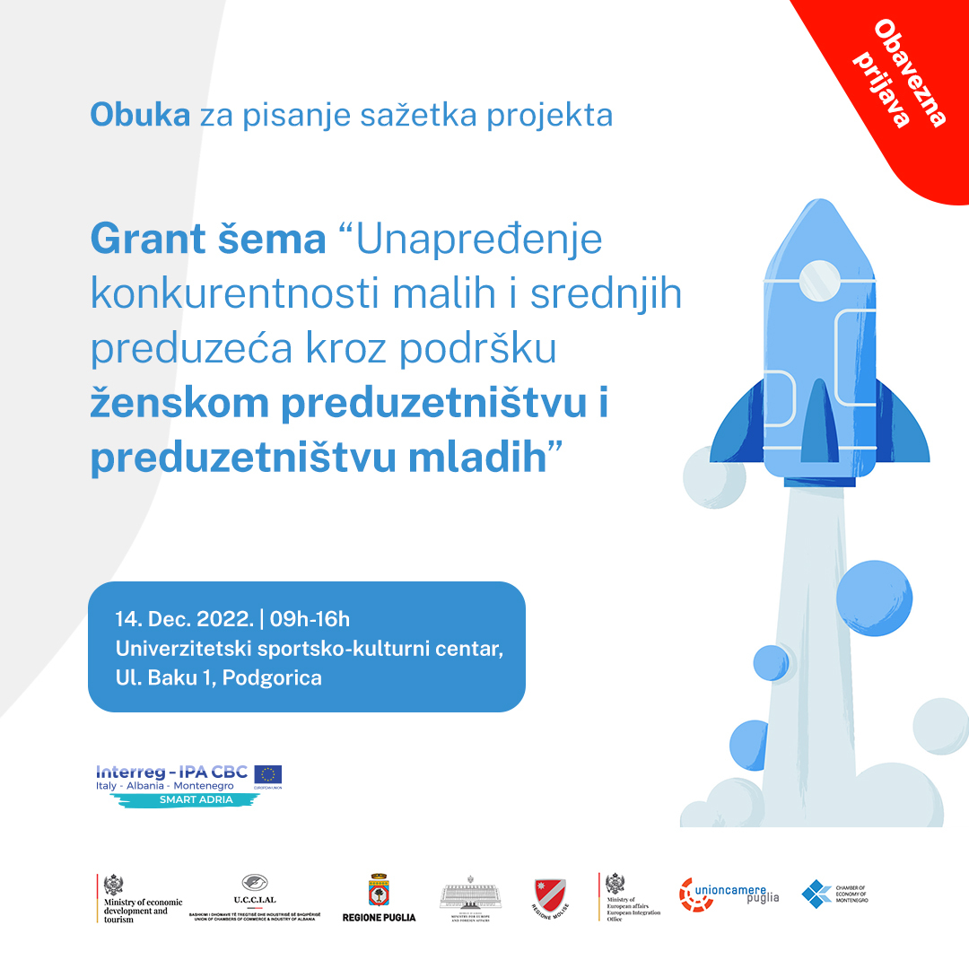

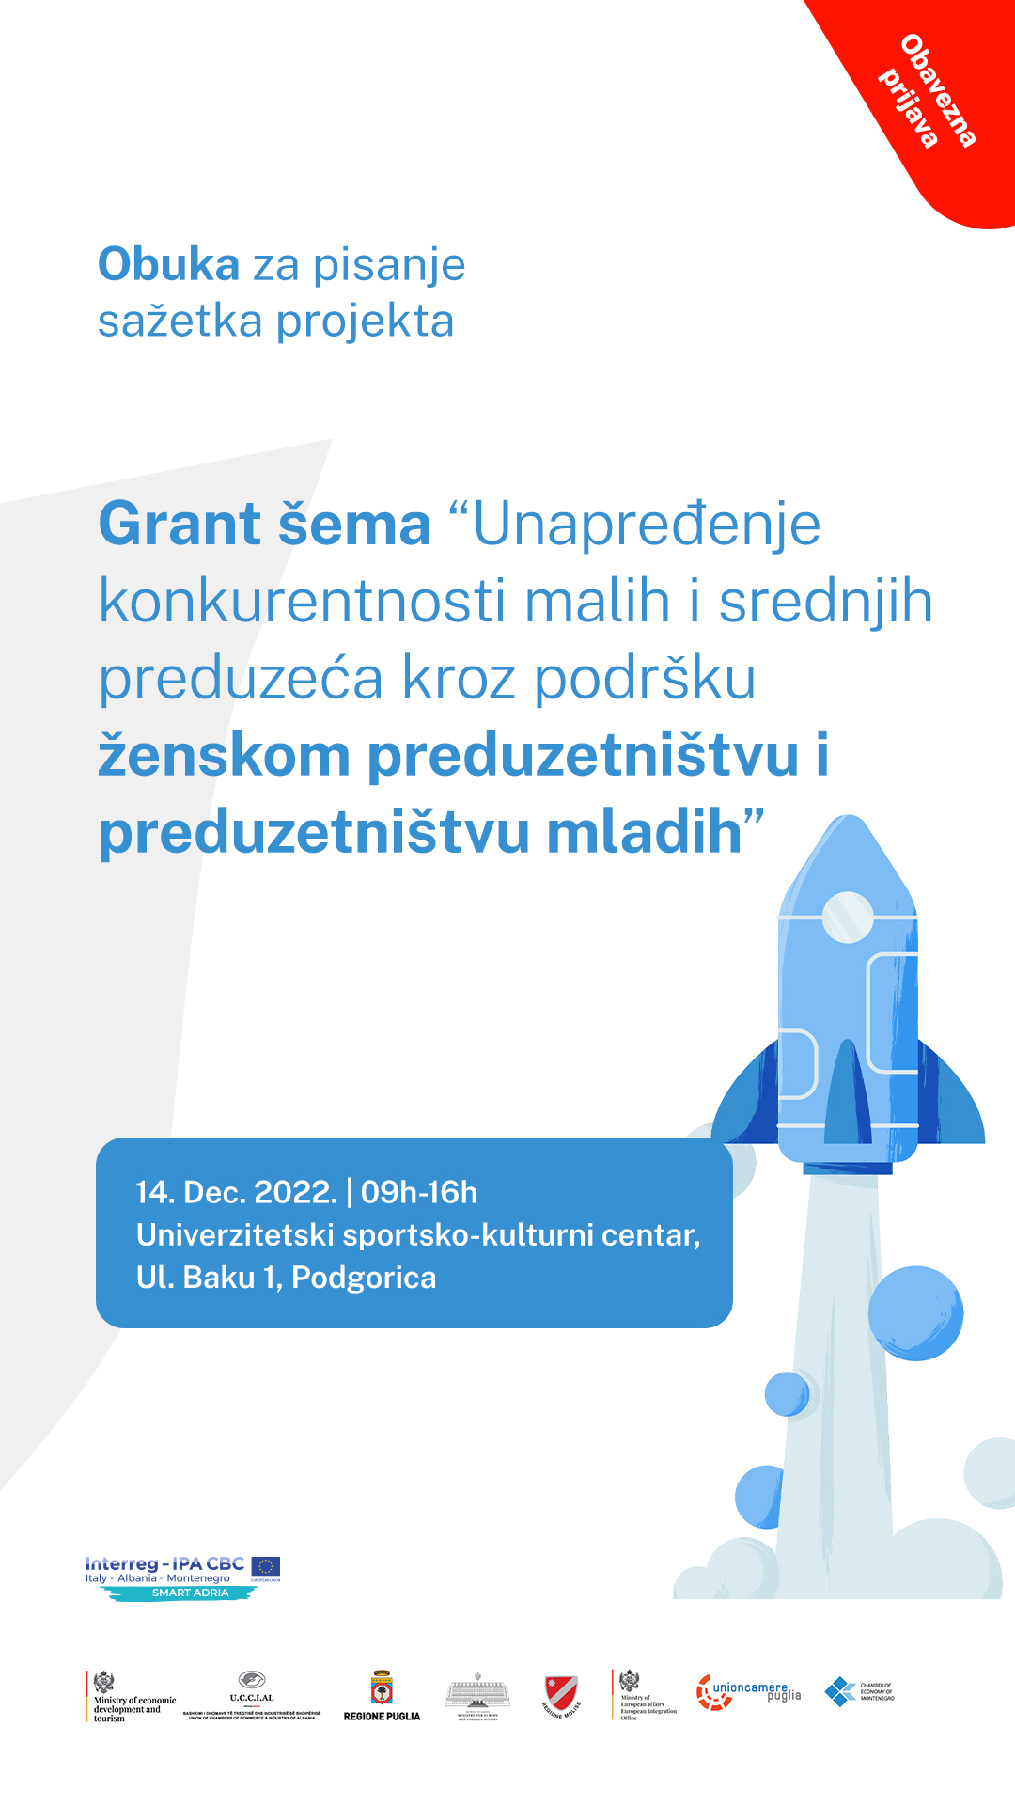

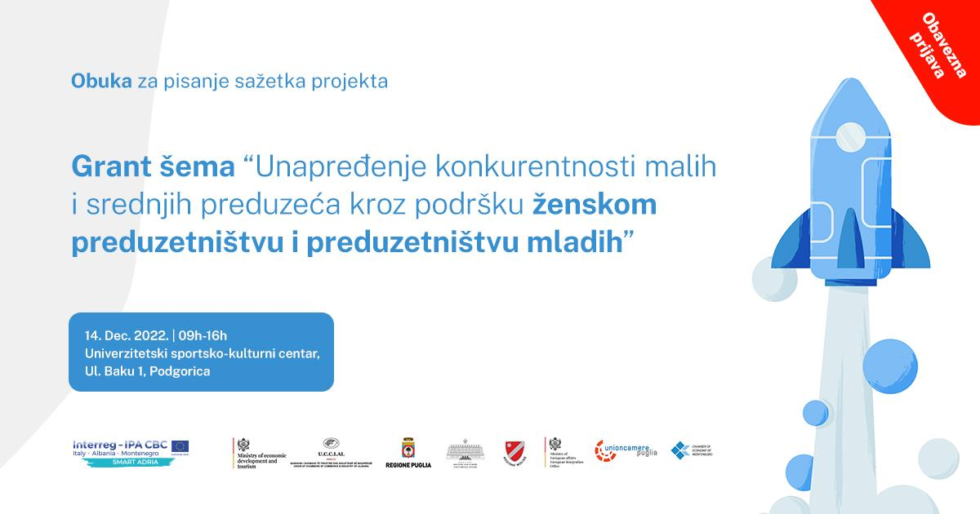

Support for the implementation of the S3 smart specialization strategy through projects

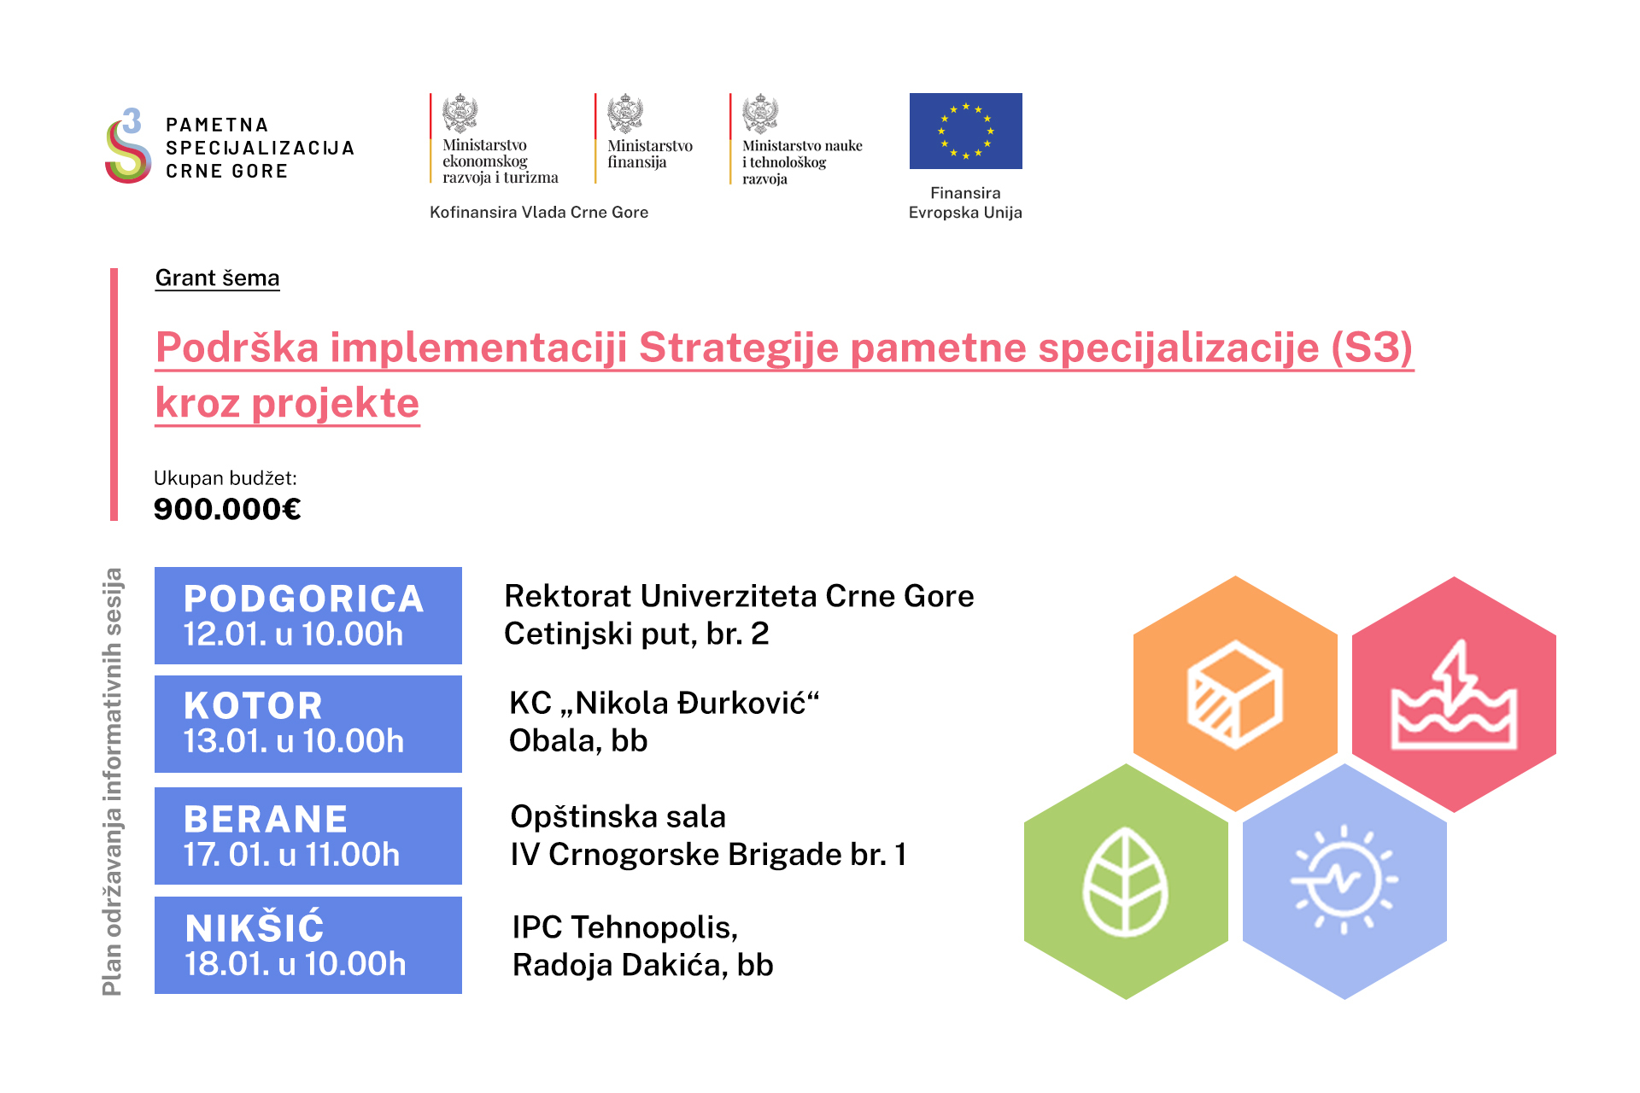

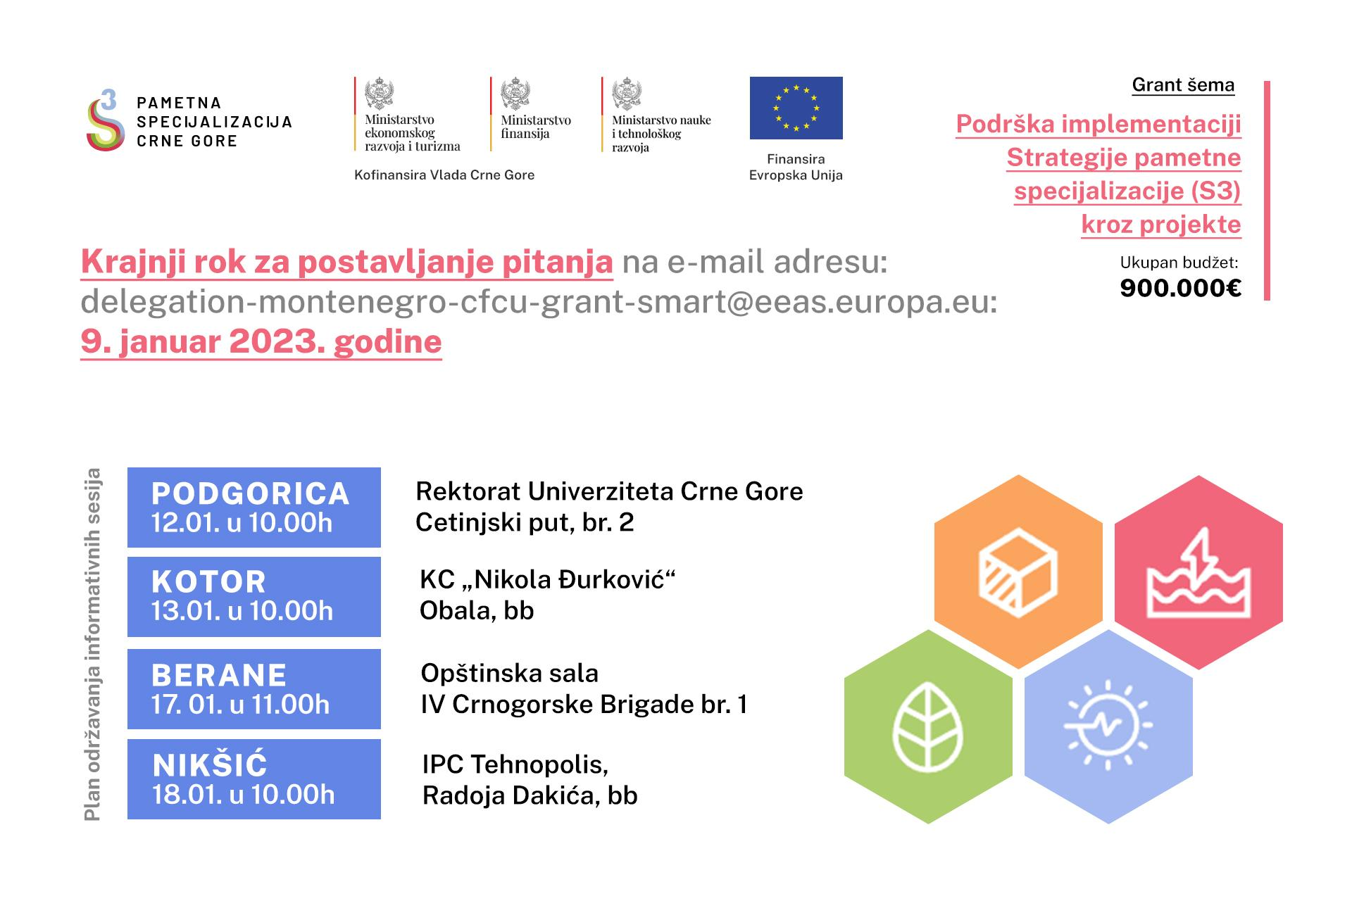

In addition, Smart Adria Blue Growth (SABG) project delivered the following events for blue growth related services:

Online Blue Growth Conference

- Date: January 25-27, 2021

- Location: Online

- Topics: Presentation of the Blue Economy Mapping Study, sustainable practices, and policies for blue growth.

- Benefits for SMEs: Gave SMEs access to valuable research findings and networking opportunities with stakeholders, enhancing their knowledge and visibility in the blue economy.

Trend Watching and Networking Event No. 1

Date: June 23, 2021

-Location: Ada Bojana, Montenegro

- Topics: Establishing a supporting network of Blue Labs

- Benefits for SMEs Facilitated networking and collaboration opportunities among SMEs, enhancing their ability to share knowledge and resources.

Cross-Border Blue Growth Conference

-Date: January 25-27, 2021

- Location: Online

- Topics: Promoting the application of Smart Specialization Strategies (S3) in the Adriatic-Ionian region.

- Benefits for SMEs: Provided a platform for SMEs to showcase their innovations and connect with potential partners and stakeholders in the blue economy.

Spring School

- Date: May 11-13, 2022

- Location: University of Molise, Termoli, Italy

- Topics: Sustainable use of resources in marine and coastal areas.

- Benefits for SMEs: Offered knowledge on sustainability practices that SMEs can implement, improving their operational efficiency and market competitiveness.

Study Visits

- Date: September 23-24, 2021 (Italy) and November 8-11, 2021 (Albania)

- Locations: Regions of Puglia and Molise (Italy) and Albania.

- Topics: Best practices in blue growth and sustainable fisheries.

-Benefits for SMEs: Provided firsthand learning experiences and insights into successful practices that SMEs can adopt to enhance their operations.

These events collectively aimed to equip SMEs with knowledge, networking opportunities, and practical insights, fostering their development within the blue economy sector.