O.T2.1 – 1 cross-border Blue Growth Cluster;

Information about O.T2.1 – 1 cross-border Blue Growth Cluster;

- Description of the output in accordance with application form:
1 cross-border Blue Cluster with the aim of putting together all public, and private actors working on SME growth issues will be established covering Albania, Montenegro and Italy, thanks to the leadership of local partners and support of Associated partners. This is the main output of project activities T2.1, T2.2 and T2.3.

- Output indicator:
Number of business and research institutions involved/offering non- financial support.

- Due date in accordance with application form:
March 2023;

- Cluster description:
The Blue Growth Cluster Association of Montenegro was registered on May 13, 2022. as a non-governmental association. The main goal of the Cluster is the networking of as many private sector institutions as possible, as well as public administration related to the area of ​​blue growth, as well as the connection of micro, small and medium-sized enterprises in the cross-border area, and the improvement of conditions and the cross-border market in this and other areas with a focus on the economy and tourism.

The association strives to be the bearer of sustainable development activities and solving potential problems for all mariculturists and fishermen in the country, as well as having a key role in restarting the fishing industry through a fish processing plant.

The Blue Growth Cluster Association of Montenegro has the following goals: Networking of economic and natural persons operating in the field of blue growth (fishing, mariculture, maritime traffic, shipbuilding, maritime surveillance, research of marine resources) into a single national cluster; Promotion of "blue technologies" and their transfer to association members; Promotion and application of innovations in the blue growth sector; International promotion of blue growth clusters and networking with clusters at the regional and European level; Achieving and satisfying common interests and needs of members and other citizens in the field of blue growth and promotions at the national level; Liaison with competent public administration bodies (ministries, agencies, etc.) and active involvement in the work of the association through management bodies and the supervisory board; Developing and improving voluntary work in the field of humanism and solidarity, and providing various forms of assistance to citizens in case of natural disasters; Connecting blue growth with sustainable development and tourism; Carrying out other jobs and tasks entrusted by competent authorities and other institutions, which are in accordance with the goals of the association.

Association Blue Growth Cluster Montenegro carries out the following activities: Promotion of all sectors of "Blue Growth" at the national and international level; Participation in national and international associations dealing with all or certain blue technologies; Participation in project competitions at the national or international level; Providing consultations, advice and recommendations regarding the legal order and realization of business ideas; Preparation of studies in the field of blue technologies (fisheries, mariculture, maritime transport, shipbuilding, maritime surveillance, research of marine resources, research of renewable energy sources from the sea and others); Cooperation with all state and local institutions in Montenegro in order to improve all types of cooperation between association members and local and state institutions.

- Cluster members:
Companies | Economic sector | Contact cell | e-mail
1. ,,Marixperience consulting“ doo Budva | Turizam | 38268441172 | marija@mariexpirience.com
2. ,,MM ribarstvo“ doo Cetinje | Ribarstvo | 38269914110 | mmribarstvodoo@gmail.com
3. ,,Asenvirocon“ doo Kotor | Naučna djelatnost | 38163281209 | radoje.lausevic@gmail.com
4. ,,Maestralfish“ doo Tivat | Ribarstvo | 38269316429 | nabavka@montefish.me
5. ,,Mariva Montenegro“ doo Kotor | Ribarstvo | 38269419498 | boban.pejovic88@gmail.com
6. ,,Fra Craft“ doo Kotor | Brodogradnja | 38269047978 | frakraftmontenegro@gmail.com
7. ,,Vuksanović“ doo Budva | Ribarstvo | 38269845225 | aquariusbudva@gmail.com
8. ,,Private Conciegre“ doo Budva | Turizam | 38267444118 | sales@pricateconcierge.me
9. ,,Global rent Cuce“ doo Kotor | Preduzetnik | 38267217327 | krivokapicmiso@t-com.me
10. ,,Moric“ doo Herceg Novi | Turizam poljoprivreda | 38267603535 | moric@t-com.me
11. ,,Leona & Aleksa“ doo Budva | Ribarstvo | 38269275086 | leonaialeksadoo@gmail.com
12. Institut savremenih tehnologija Crne Gore - Podgorica | IT tehnologije | 38267819450 | office@imtm.me
13. ,,Trio Mare“ doo Bar | Ribarstvo | 38268066088 | triomare1@gmail.com
14. ,,Blue Fish“ doo Bar | Ribarstvo | 38269924565 | montenegro.bluefish@gmail.com
15. „Bild Studio“ doo Podgorica | IT sektor | 38267000275 | info@bild-studio.com
16."Montefish" | prodaja ribarstvo | 38232675250 | info@montefish.me
Entrepreneurs
1. Slavko Radunović | Brodogradnja | 38267508826 | meditera@t-com.me
2. Aleksandar Stanojlović | Ribarstvo | 38268428920 | stenlizl@gmail.com
3. Ognjen Savčić | Razno | 38268553458 | osavcic@gmail.com
4. Dušan Gregović | Ribarstvo | 38267287103 | dusangregovic@gmail.com
5. Siniša Stanojević | Akvakultura (musulje i kamenice) | 38269089759 | sinisa.stanojevic1a@gmail.com
6. Branko Vujičić | Ribarstvo | 38269254417 | mjbt@t-com.me
7. Luka Sekulić | Ribarstvo | 38269275086 | role7@t-com.me
8. Maja Vuletić | Turizam | 38267304580 | majavuletic19@gmail.com
9. Luka Milošević | Uzgoj školjki | 38269523557 | milosevicluka@zahoo.com

The Cluster was also provided with the following list of Italian and Albanian stakeholders from the quadruple helix, identified in the project mapping study, in order to establish the durable and sound cross-border cooperation foreseen by SABG. Here is a list of the involved stakeholders:

University/research | Civil Society
- ● Polytechnic of Bari  - ● University of Bari  - ● University of Salento  - ● University of Foggia  - University of Molise  - ● Zooprophylactic Institute of Puglia and Basilicata  - ● CNR  - ● COISPA  - ● CIHEAM  - ● CMCC  - ● CETMA  - ● ENEA  - 1. Agriculture University of Tirana, Department of Aquaculture and Fisheries;  - 1. Agriculture University of Tirana, Department of Rural Tourism Management;  - 2. Polytechnic University of Tirana, Faculty of Natural Science,Department of Biotechnology.  - 3. University of Tirana, Faculty of Economy, Department of Marketing -Tourism;  - 4. University “Ismail Qemali” of Vlora, Naval Engineering Department;  - 5. Tourism and Hoteliery Managment, “Ismail Qemali” University of Vlora  - 6. Naval Vocational Schol of Vlora  - 7. University “Alexander Moisiu”, Durres, Navagation Engeeneering Department,  - 8. University “Alexander Moisiu”, Durres, Faculty of Economy, Tourism Managment Department, Univertity of Tirana  - 9. Fisheries Research Institute in Durres  - 10. Hydro - Fisheries and Aquaculture Research Center (Private/NGO)  - Institute of GeoSciences, Energy, Water and Environment, Tirana. | ● Association (Assopesca, ANAPI, Federpesca, Federcoopesca, Legapesca Puglia, etc.)  ● Chamberre of Commerce, Unioncamere, Coldiretti  ● Environment Associations (Legambiente Puglia, WWF)  1. Albanian Fishery Associations (Vlora, Durrws and Lezha Branch)  2. Union of Chambers of Commerce and Industry of Albania,  3. Albanian Association of Tour Operators and Tourist Agencies  4. Tourism Association, Durres  5. Albanian Tourism Association (ATA)  6. “Regional Development Agency" Vlora (RDA - Vlora)  7. “Regional Development Agency” (RDA-Durres)  8. “Regional Development Agency” Lezha (RDA- Lezhë)  9. Ionian Center for Environment, Media and Information (AJMMI)  10. Cultural Center “AULONA"  11. Cultural- Environmental Association BORSHI  12. Institute of Nature Protection in Albania - INCA  13. Albanian Renewable Energy Association (AREA)  14. Albanian Association of Information and Technology (AITA)  International Agencies  15. The United Nations Development Programme (Marine and Coastal Protection Zone Project)  16. GIZ (Integrated Sustainable Development of the Southern Coastal Region/Integrated Waste Management and Marine Litter Prevention in the Western Balkans)  17. Italian Development Agency/IPA project “Blue Fisheries”  Austrian Development Agency/ Project on water waste management
Industry | Institutions
● Spin-off  ● Start-ups  ● Traditional operators  ● Consulting companies  ● Districts (i.e. DARe Puglia)  Spin-off  1. Landways  2. Adriatika Investiment  3. Rozafa Sea Food  4. Andromeda Marine Aquaculture  5. Almarine Sh.a  6. I.N.C.A Nord Fish Albanian Company  Start-ups  1. Fishing Cooperative “Divjaka”(54 members)  2. Fishing Cooperative “Kodra Fish”  3. ONIC SEA PRODUCTS INT " SH.A  4. Fishing Center Oriku  Traditional operators  1. “Dajlani Nartw” SH.p.k  2. Rozana Maritime Service  3. Lissus Daria  4. Palace Hotel and Spa  5. EURO-FISH  6. Acquario Sali Peshku Sh.p.k  7. Gold Fish Sh.p.k  8. KAP  9. Albanian Travel and Hospitality Services  10. Vangjel 2002 Sh.pk  11. Ionian Cruises  12. K. A. D  13. Flower Hotel & Spa  14. Kompleksi Turistik Bleart  15. Harmonia Premium  16. Prince Adriatic resort  17. ALBTOURS"D"-VAS tour operatore  Consulting companies  1. Durres Fishing Port Management Organisation (OMPD) Sh.p.k  2. Portal Authority in Saranda Sh.a  3. Portal Authority in Shwngjin Sh.a  4. Portal Authority in Vlora Sh.A  5. Albanian Marine Register SH.A  6. Orion Maritime Consulting  7. Teuta Maritime  Vlora Maritime Training Center (VMTC) | ● ARTI  ● GAC  ● Puglia Region  ● Molise Region  Coastal municipalities  ● Centro Regionale del Mare (CRM, ARPA Puglia)  ● Puglia Sviluppo  ● AdB  ● Port authorities  ● Coastal guard  ● Chambers of Commerce, Unioncamere  1. Ministry of Agriculture and Rural Development / Department of Strategy and Policies on Fisheries and Aquaculture  2. Directorate of Fisheries and Aquaculture Service  3. Ministry of Tourism and Environment / Department of Sea, Sun and Sand Tourism Program Development  4. Ministry of Tourism and Environment / Department of Environmental and Biodiversity Protection;  5. National Tourism Agency  6. National Agency of Protected Areas, in Albania (AL)  7. Ministry of Infrastructure and Energy / Department of Territorial Development Policies and Strategies  8. Ministry of Infrastructure and Energy/ Department on Renewable Energy Development Programs  9. The National Agency of Natural Resources  10. Ministry of Culture / Department of Program Development on Cultural Herritage  11. Institute of Cultural Herritage Protection  12. Butrint National Park  13. Vlora Regional Directorate of Cultural Heritage  14. Ministry of Europe and Foreign Affairs / Directorate for Inter-Territorial Cooperation  15. Local Government: Vlorw Municipality,Sarandw Municipality, Durrws Municipality and Lezhw Municipality

- Cluster registration document:
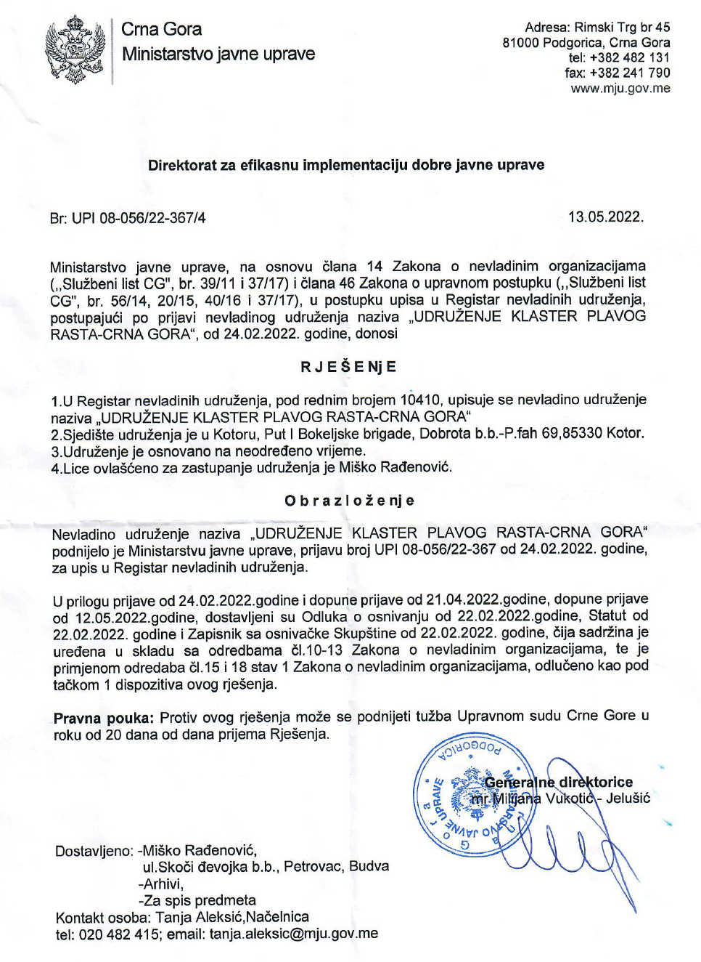

- Cluster activities:
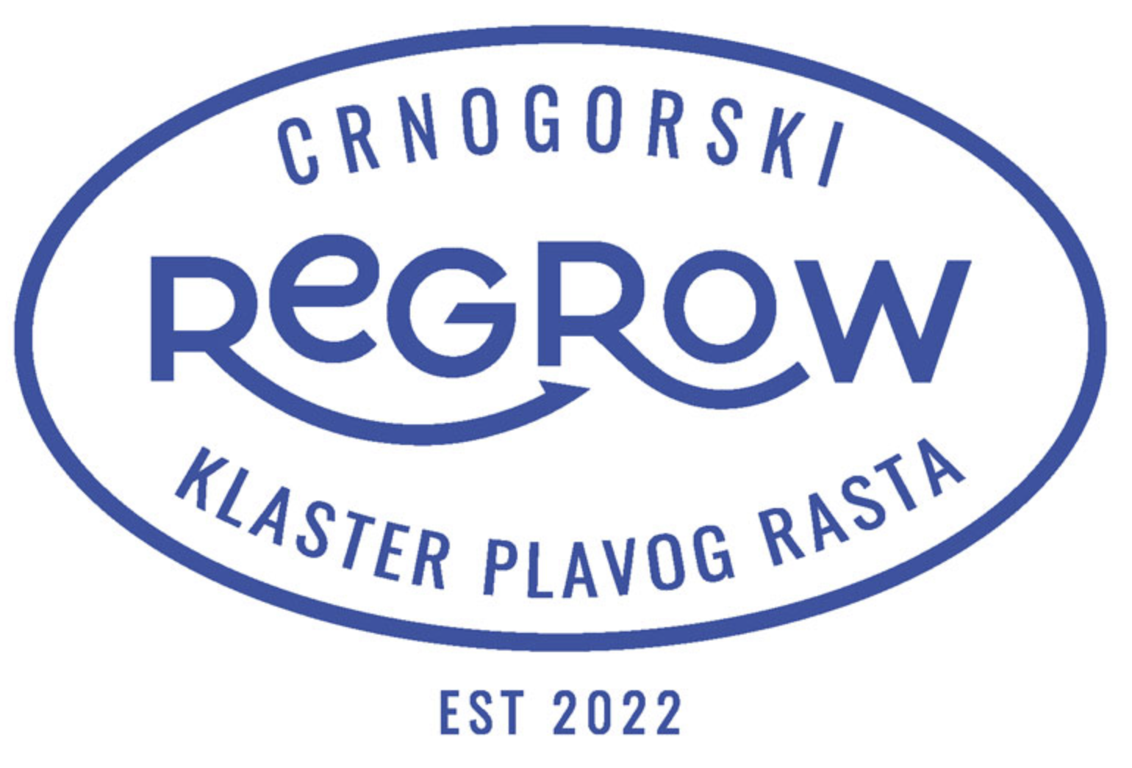

During May and June 2022, meetings were held with representatives of Montenegrin fishermen. During the discussion, the biggest problems in their work were identified:

Inadequate cooperation with government institutions in the field of fisheries and mariculture
High prices of new ships and equipment
Absence of organized redemption
Lack of organized storage and lack of chambers, and often dry ice
The absence of an organized sale of all caught fish
There is no possibility of joint export
No processing of surplus (unsold) fish
The impossibility of joint (joint) fishing of larger quantities of fish in the season.
Slow implementation of legal procedures by relevant institutions
Poaching

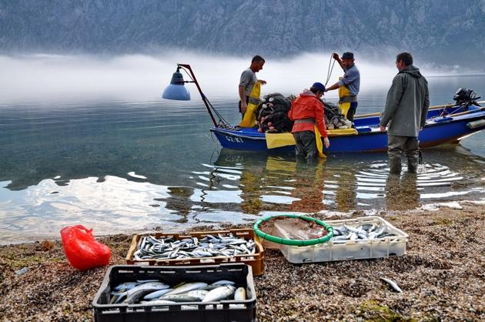

Innovation related activities:

In accordance with the work plan of the Blue Growth Cluster Montenegro, September 7, 2022. In 2008, the manager of the Cluster, Dr. Miško Rađenović and Dr. Mirko Đurović, representative of the Institute of Marine Biology, held a meeting with the member and president of the Cluster Assembly, Mr. Ognjen Savičić, an innovator from Budva, who managed to make an electric board with his own knowledge and investment surfing in his workshop in Budva.

Mr. Savičić shared his experiences in the way of making his products, his thoughts on the part of commercialization as well as the lack of equipment that would benefit him in the future in the commercialization of his product. He also worked very hard on the promotion of electric boards in Budva, where he gave lessons in riding electric boards to interested surfing enthusiasts.

It was emphasized that in the further improvement of his product, the help of the scientific community in the field of electronics and material development would be welcome, as well as that in the coming period he would apply to some of the national and/or international calls for funds to improve the performance of the electric board.

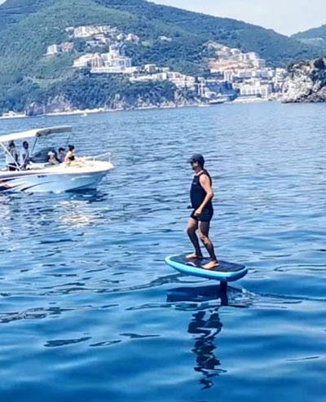

Production related activities:

The manager of the cluster, Dr. Miško Rađenović, visited the members of the blue growth cluster - the fisheries sector. The meetings were held in the Bar marina, where the members have a mooring for their boats.
Dragoljub Bajković, the owner of the fishing company Orka doo, presented his product fish pate, which he produces exclusively from his own catch. He markets the pâté via social networks and delivers it with his vehicle to all towns on the coast and Podgorica. At the time of the visit, his fishing boat was dry docked due to the necessity of annual regular servicing.

The high potential of his product was emphasized in terms of the modernized capacity of his product. It was pointed out the possibility that his product could be processed and packaged in the future fish processing plant in Kotor, where all the necessary conditions would be provided for obtaining all the certificates in the area of ​​food safety and placing the product on the market.

